***Mini Project Report***

Virtual Assistant

***CHIRAG VERMA - 16010221036***

***ABHIRAJ KULKARNI - 16010221031***

***Code Implementation for our Project:***

***The code is divided into 3 parts:***

1. *Importing the pyttsx3 module and setting up the voice for assistant.*
2. *Creating different functions.*
3. *Designing the further part of GUI with if...elif…else statements, etc.*

*CODE:*

import pyttsx3 #pip install pyttsx3

import speech_recognition as sr #pip install speechRecognition

import datetime

import wikipedia #pip install wikipedia

import webbrowser

import os

import smtplib

engine = pyttsx3.init('sapi5')

voices = engine.getProperty('voices')

# print(voices[1].id)

engine.setProperty('voice', voices[0].id)

def speak(audio):

engine.say(audio)

engine.runAndWait()

def wishMe():

hour = int(datetime.datetime.now().hour)

if hour>=0 and hour<12:

speak("Good Morning!")

elif hour>=12 and hour<18:

speak("Good Afternoon!")

else:

speak("Good Evening!")

speak("I am Jarvis Sir. Please tell me how may I help you")

def takeCommand():

#It takes microphone input from the user and returns string output

r = sr.Recognizer()

with sr.Microphone() as source:

print("Listening...")

r.pause_threshold = 1

audio = r.listen(source)

try:

print("Recognizing...")

query = r.recognize_google(audio, language='en-in')

print(f"User said: {query}\n")

except Exception as e:

# print(e)

print("Say that again please...")

return "None"

return query

def sendEmail(to, content):

server = smtplib.SMTP('smtp.gmail.com', 587)

server.ehlo()

server.starttls()

server.login('youremail@gmail.com', 'your-password')

server.sendmail('youremail@gmail.com', to, content)

server.close()

if __name__ == "__main__":

wishMe()

while True:

# if 1:

query = takeCommand().lower()

# Logic for executing tasks based on query

if 'wikipedia' in query:

speak('Searching Wikipedia...')

query = query.replace("wikipedia", "")

results = wikipedia.summary(query, sentences=2)

speak("According to Wikipedia")

print(results)

speak(results)

elif 'open youtube' in query:

webbrowser.open("youtube.com")

elif 'open google' in query:

webbrowser.open("google.com")

elif 'open stackoverflow' in query:

webbrowser.open("stackoverflow.com")

elif 'play music' in query:

music_dir = 'D:\\Non Critical\\songs\\Favorite Songs2'

songs = os.listdir(music_dir)

print(songs)

os.startfile(os.path.join(music_dir, songs[0]))

elif 'the time' in query:

strTime = datetime.datetime.now().strftime("%H:%M:%S")

speak(f"Sir, the time is {strTime}")

elif 'open code' in query:

codePath = "C:\\Users\\Haris\\AppData\\Microsoft VScode\\Code.exe"

os.startfile(codePath)

elif 'email' in query:

try:

speak("What should I say?")

content = takeCommand()

to = "yourEmail@gmail.com"

sendEmail(to, content)

speak("Email has been sent!")

except Exception as e:

print(e)

speak("Sorry my friend. I am not able to send this email")

***Flowchart for the above code:***

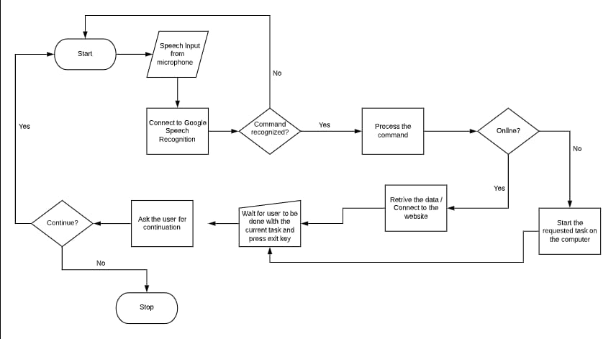

***Output for the above code:***

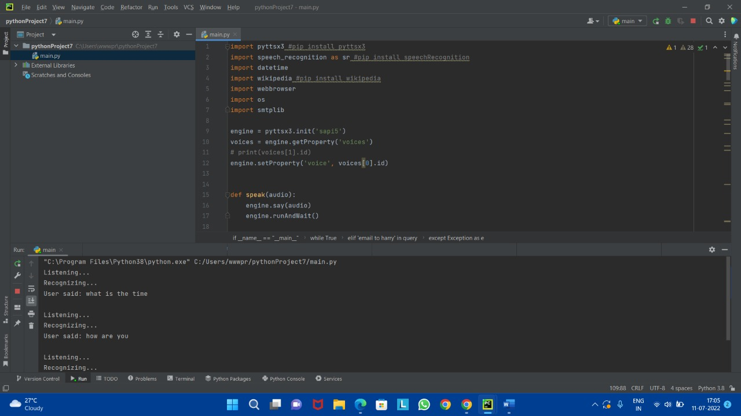

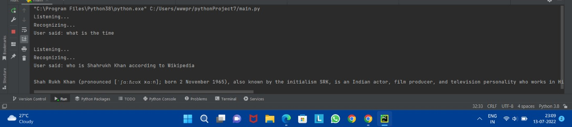

***Working of the code:***

1. *With the help of Python, we have created a mini project named* ***VIRTUAL ASSISTANT****.*
2. *It takes microphone input from the user and returns string output*
3. *The code is designed with the help of If…elif…else statements and Functions.*
4. *The Program is capable of opening websites like Google, Youtube, etc., in a web browser.*
5. *It is capable of opening your code editor or IDE with a single voice command.*
6. *Simple Mail Transfer Protocol (SMTP) is a protocol that allows us to send emails and route emails between mail servers.*
7. *The pyttsx3 is a python library that will helped us to convert text to speech. In short, it is a text-to-speech library.*
8. *The speechRecognition module takes microphone input from the user and returns string output*
9. *Then, we create the GUI further with the help of If…elif...else statements.*